**GTCFibre : Centralized Technical Management of Network Nodes**

IFOTEC, as a specialist of fiber optic transmission which already supplies active access equipment for optical fiber networks up to the subscriber, to serve both companies (FTTO, FTTE) and individuals (FTTH), has developed a solution of centralized technical management over optical fiber, GTCFibre, to manage remote devices through an Ethernet network.

GTCFibre is equipped with advanced features to characterize:

* The technical environment of the network nodes through its numerous interfaces (analogue and contact closure inputs/outputs, serial links and Ethernet, ...)
* The climatic environment using temperature and humidity probes and the possibility of connecting other sensors (smoke, ...)
* The security environment by the capability to connect surveillance cameras or other intrusion detection means,
* The energy consumption, both by remote meter reading, and and by measuring the local power supply characteristics.

Each GTCFibre module is also a control instrument:

* To optimize the equipment climatic environment and the energy consumption by the capability to programmed triggering of events, remotely controllable
* To manage access control

The GTCFibre solution for remote management of telecom or energy network nodes, is also used for other applications such as public lighting management, city management (traffic, video surveillance, information panels, ...) and centralized technical management of the premises.

**Examples of centralized technical management for different network nodes**

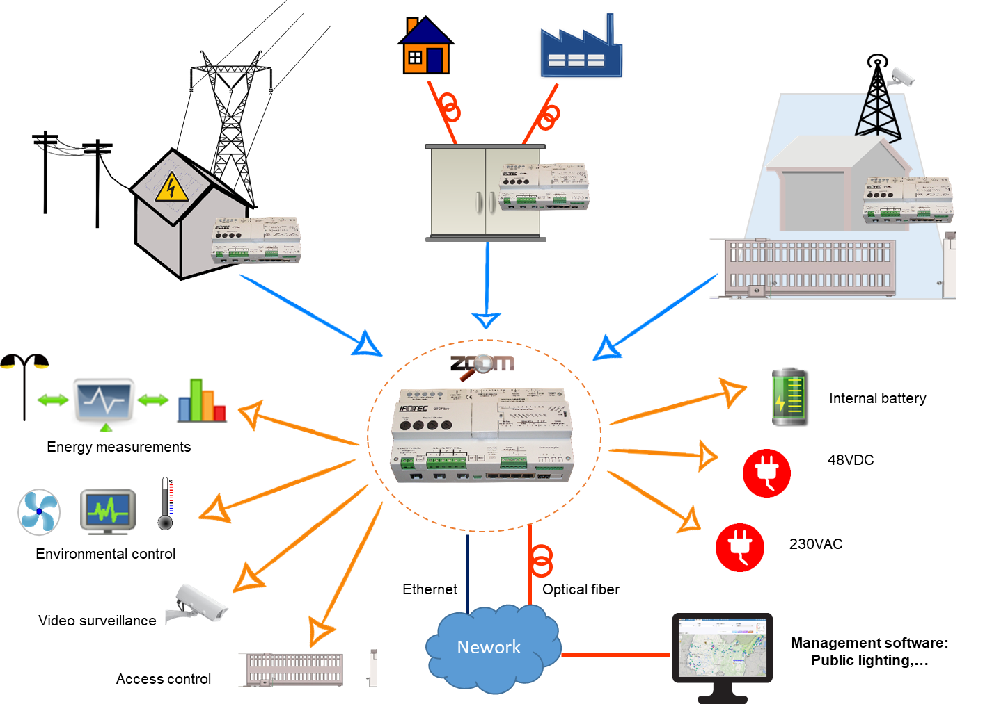

**GTC Fiber: Main Features of the Network Node Solution**

GTCFibre series centralized management modules connect applications to an Ethernet network for monitoring and remote control.

This version is particularly dedicated to the centralized management of cabinets or control rooms (shelters, ...) scattered throughout an area.

Seen from the network, the GTCFibre module is a neutral element that, through an optical fiber or copper Ethernet link, or even a radio link, makes it possible to remotely manage the entire technical environment of a network node.

Materially, it is designed to be fitted directly into the electrical panel (width 12 units) or to be fixed onto a DIN rail.

The equipemnt uses both the power supply and the 48VDC network.

The equipment is powered by both the mains and the 48VDC network, which at the same time allows it to characterize the 48VDC energy cabinet operation (integrated voltage measurements) and the electrical network (remote meter reading interface ; internal measurements of, mains voltage, current, active and reactive powers, harmonics, ...).

In the event of a complete power failure, the product is equipped with an internal battery to maintain the central unit operation and network access ten minutes to put the site safely and send by the network a quick and reliable diagnosis.

GTCFibre module has many inputs-outputs of command control:

* Opto-isolated Contact Closure (CC) inputs and ouputs
* Analog Inputs and outputs
* 2 RS232/RS422/RS485 serial ports
* Ethernet ports, …

It is also possible to remotely control the supply of three independent power applications on the mains.

power supply.

This GTCFibre module also measures the environment. It is supplied with two probes to measure the

temperature in two points of the room, as well as humidity, which allows him to directly control

ventilation / air conditioning devices via the appropriate inputs and outputs.

Equipment can also be managed by a web server; it is also compatible with SNMP and Syslog protocols,

GTCFibre dedicated software makes it possible to control all the many features, individually and in groups, of all the units (in thousands) present in a region.

 

